**Chandana K**(chandanakchandu70@gmail.com)

**Cloud Computing & DevOPS Essentials | March 2021| Day2**

**Assignment**

Screenshot 1 : EC2 instance page

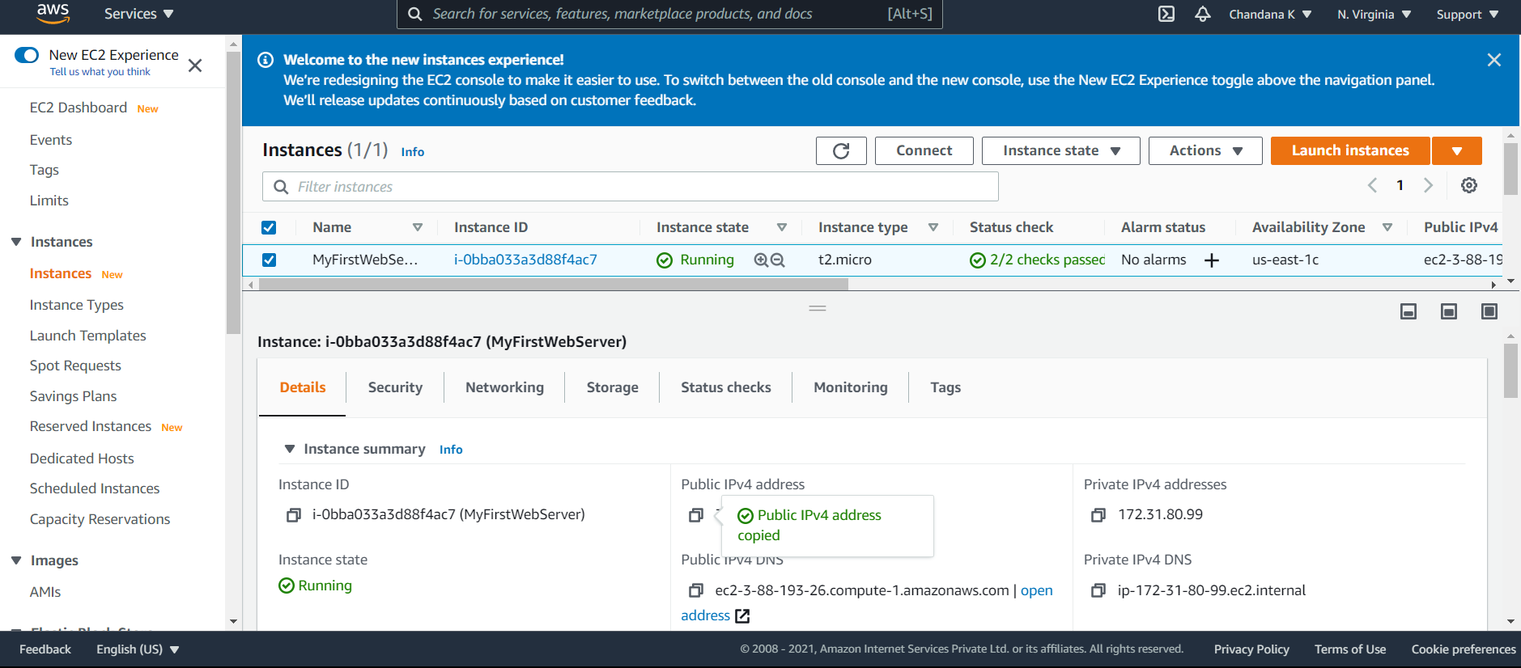

Screenshot 2 : EC2 instance page with the created new instance and public IP address

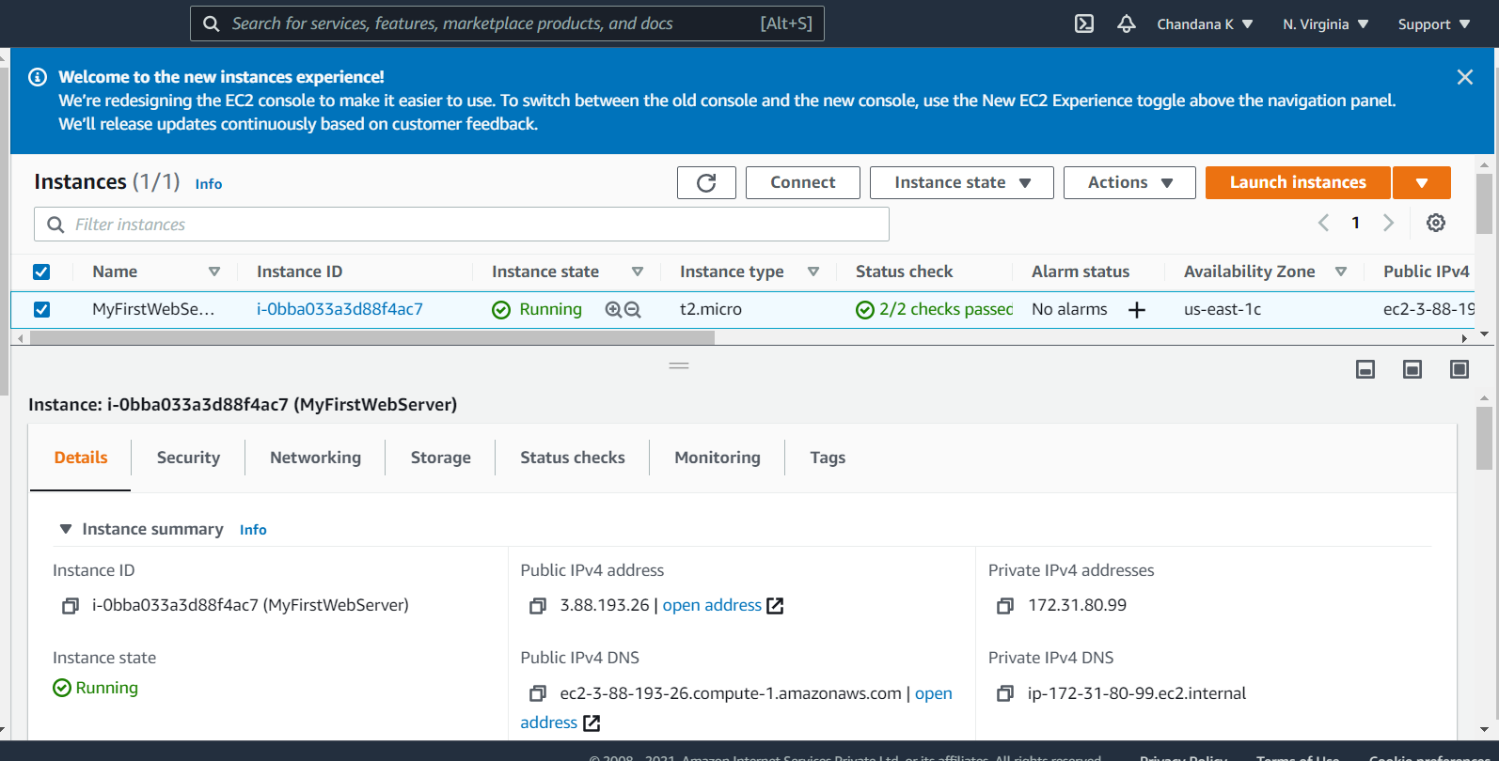

Screenshot 3 : Welcome to nginx web page

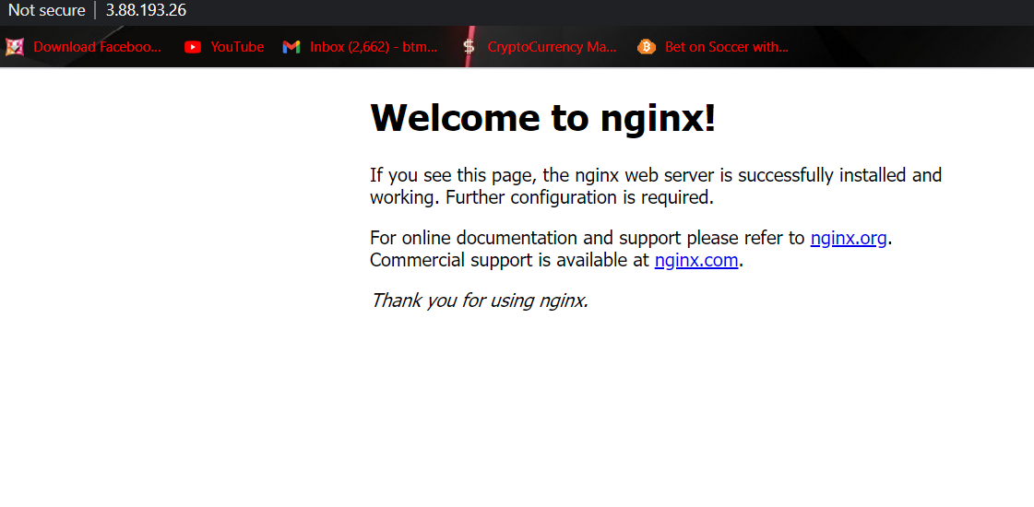

Screenshot 4 : Command prompt page

